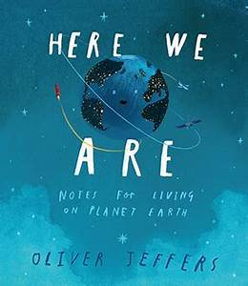
Name________________
HERE WE ARE

- The deepest part of the ocean is called the Challenger Deep and is located beneath the Pacific Ocean. The Challenger Deep is approximately 11,033 metres deep. The tallest mountain on Earth is Mt. Everest and is 8,850 metres tall. How far is it from the deepest part of the ocean to the tall part on Earth? Write your answer in metres and in Kilometres ( 1000 metres = 1 Kilometre)

- How many hours would it take you to travel from the bottom of the Challenger Deep to the top of Mt. Everest if you were travelling at 5 KMS per hour?

- There are about 7, 327, 450, 667 people on Earth. Write this number in expanded form using words for the numbers. ( example 12, 345 would be ten thousand + two thousand + three hundred + four tens + five ones )

- What is the area of the grid below? ______________________

What is the perimeter? ______________________

The surface of the Earth is 70% water and 30% on the surface is land. Using a blue and a green marker, show this on the grid below.

1cm

- Using the graph below estimate how many M2 the iceberg is above the water and how many M2 the iceberg is below the water.

1M
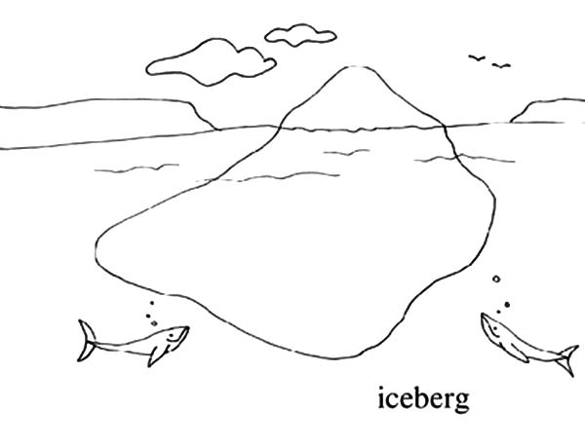
Above____________________

Below____________________

