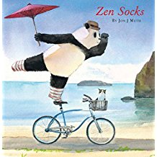
Name__________________
Zen Socks

- Banzo was a great swordsman. He started learning to use his sword at 12 years old. He practiced day and night until he finally became a master swordsman at the age of 57. The only vacation time that he took was at Chinese New Year when he would take 6 days off and travel to visit his family far away. Because he lived far away from them on Mount Futara, he was only able to make it home every three years. How many days off did Banzo have in total while he was learning to be a master swordsman?

- Stillwater loves his cookies!! The cookies that he buys have 14 chocolate chips in each cookie. If he ate 7 and a half cookies how many chocolate chips would have eaten?

- Stillwater loves to eat bamboo. He loves it so much he puts it in cakes, cookies and eats it straight out of the ground. The problem is that the bamboo he eats grows far away on the mountain side. If Stillwater rides his bike to the mountainside, collects the bamboo, then drops some off at the bakery where the cakes are made, waits an hour, then rides home with the cake…. how long will it take him if he peddles 4 kms an hour?
- You get to choose the route that he takes.
- The lines are the paths that he can take and are 1 km per side
- Draw the route on the lines that you want him to take
1km

Total time ______________

